House Histories

The history of the houses of Strawberry Hill

1 Gloucester Villas - 53 Pope’s Avenue

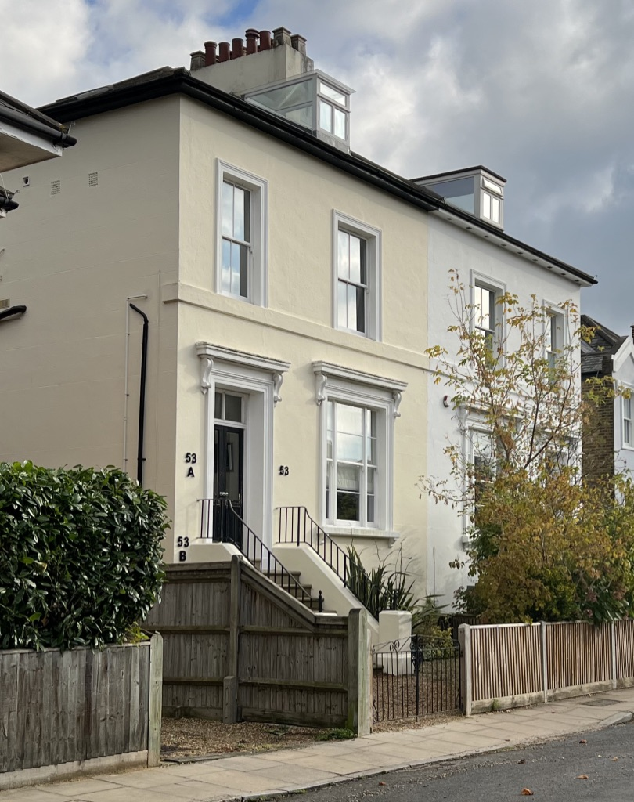

Written by Andrew Miller for Strawberry Hill Residents’ Association
November 2021

House histories – 53 Popes Avenue

In the spring 2019 issue of the Strawberry Hill Residents’ Association Bulletin an offer was made to all residents of the area. Peter Lamb of the SHRA Committee had offered a service which would involve research on the history of the houses of Strawberry Hill. This fits with another undertaking by SHRA to research and publish, via its website, a number of street histories under the name, Streetwise. Clearly, the two projects are linked as streets comprise collections of individual houses. In return for the time of the volunteer researchers, householders in receipt of a report on their house history, are invited to donate to SHRA (the suggested donation is £25). This is not a reflection of the actual time involved in doing the research and writing up the final rep/ort.

At a minimum, the work involves:

- searching through various online genealogical databases, e.g. Ancestry, find my past, for Census data and other records;
- searching the British Newspaper Archive for references to the street and house residents;
- visiting the Local Studies section of the Richmond upon Thames Library;
- writing a report to present a coherent house history (going as far as 2000 – we did not want to intrude too much on recent residents).

53 Popes Avenue

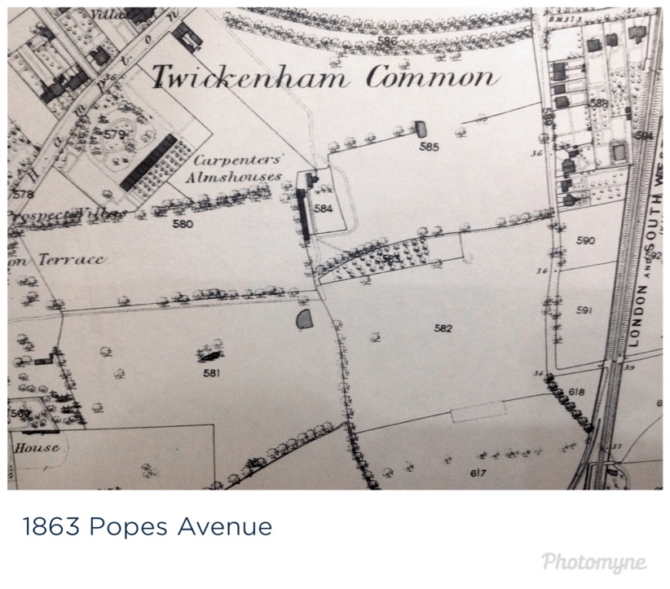
According to Anthony Beccles-Wilson’s history of Strawberry Hill the houses in this stretch of Pope’s Avenue were built between 1846 and 1864. Nos 53 and 55 are semi-detached Victorian properties next door to Batcombe Lodge No.57 and No.59 which were built by local builder Abraham Slade in 1862. No.53 first appears in a local map of 1863 (above) with the railway running along the back of the house behind the long garden of Inverness Lodge. The house does not appear in the 1861 Census, so it was probably built between then and 1863. When built, the pair of houses were called 1 (53) and 2 (55) Gloucester Villas and Pope’s Avenue was a continuation of Strawberry Hill Road.

1871-1881
In the 1871 Census, Gloucester Villas were run as a lodging house run by a woman, Parnel Dunmall, a lodging house keeper, (1811-1876) from Chelsfield, Kent, with the support of a housekeeper, Maria Donington (1854-), from Essex. The lodgers were: Mary A Smith, a 60-year-old widow and annuitant from Middlesex; Hill Toller (1846-1911) was a 25-year-old curate of Holy Trinity Church (on Twickenham Green) from Sydenham in Kent – who had attended Harrow School and Trinity College, Cambridge; Elizabeth Pendry was a 79-year-old widow who had run a public house on Hampton Road with her husband (she died in 1873); and Maria Pendry, 34, who was the unmarried daughter of Elizabeth.

By the time of the 1881 Census the head of the household was James Johnson, a 66-year-old domestic gardener, from Cambridge, who was living with his wife, Sarah aged 51. They were sufficiently prosperous to employ a general servant, Mary Hunt, aged 21 from Middlesex. There was a visitor, Annie Huson, aged 47, and a boarder, Spencer Butler aged 28, the Curate of Holy Trinity Church.

1891-1911
By 1891 the house was occupied by the Ginger family who were to stay for the next two decades. George Ginger had been born in 1838 in Aylesbury, Bucks, and in 1891 he was working as a cellarman. This was probably in the same business as in 1881 when he was a ‘wine merchant’s shopman’ living at 1 ,The Green, Heath Road, Twickenham. His wife, Elizabeth, also from Aylesbury, was a year younger than him and they had a large family: two sons – Arthur V (22) and Albert V (16) both butchers; and four daughters – Alice M (18), Emma (14) , Florence (12) and Clara (10). They had married in Aylesbury on 15 October 1861. This was straight after his return from India where he had served as a private in the 66 Berkshire Regiment of Foot in suppressing the Indian Mutiny. He would have seen many unpleasant and horrific sights during this time. In 1881, they had more children living with them: Thomas Charles (1865-), Henry George (1867-) and Edward (1871-)

This was the first year where there is evidence of the house being divided into two apartments rather being a lodging house. The Ginger family lived in four rooms and the other four rooms were occupied by Annie Wilson who was an India-born married woman aged 31 and her son William (7) born in Burma(h) (Burmah was in Afghanistan as opposed to Burma but could be an error). They were supported by Florence Randall, a general servant aged 23.

George had an interest in business and politics. He developed something called the ‘Ginger Scheme’ (Middlesex Independent, 18 October 1893) which he put in a proposal to the Brentford Board of Guardians (responsible for the Poor Law for Twickenham). It was a form of ‘welfare to work’ in which the unemployed would be put to work doing unspecified work with household refuse for the borough. He argued that this was a way of reducing the burden on ratepayers and giving the unemployed useful work – ‘a self-supporting scheme by which all persons out of work might be employed without pauperizing them’ (Acton Gazette, 2 September 1893). He offered to use land that would need to be purchased by the local council for the refuse. His scheme was criticised by trade unions for undercutting union rates but it was widely reported in local newspapers. Nothing came of the idea which was ultimately shelved by the Board of Guardians. They may have suspected his motives being more about profit than altruism.

By 1901, George Ginger was a self-employed ‘drapery traveller’ and his three daughters may have been employed to produce items that he would then sell. Both Emma and Clara were dressmakers and Florence was a ‘needleworker’. The other rooms were let to Jane Barlow aged 53 who was living on her own means. Jane had been born at 5 Great George Street in Dublin to a barrister father. She had a lady’s maid living with her, Ellie Smith aged 22 from Peckham in Surrey.

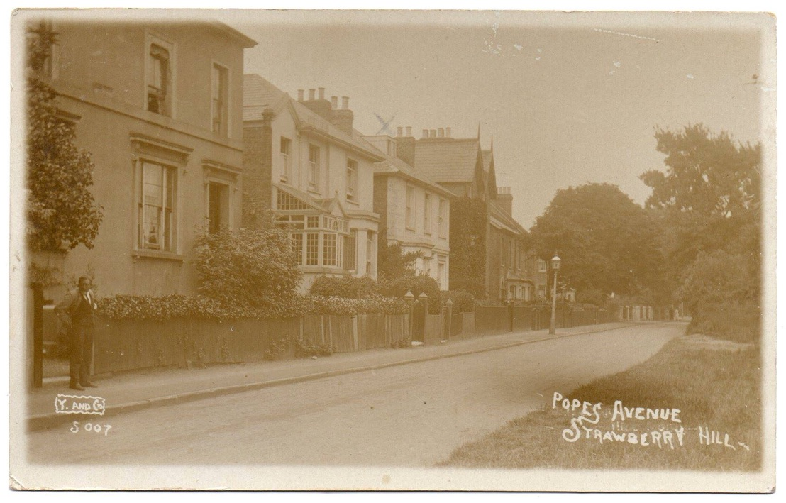

By 1911, a 73-year old George lived in the house with his wife and the unmarried Florence. Jane Barlow had a new maid, Catherine Rosabrank. The Richard Young of Teddington postcard (above) of Pope’s Avenue shows a man, probably in his sixties, standing by the gate of No.53. According to Twickenham and Teddington History Facebook site this postcard dates to 1907 which would put George as aged 69. This is most likely to be George Ginger who has come out of his house of many years to see what is going on with the cameraman who could be Richard Young. George was still living in the property at the outbreak of WW1. He died in his home town, Aylesbury, on Christmas day 1925, aged 88.

1919-1936
During this period the division of the house into two apartments became a permanent feature of life at no.53. Between 1919 and 1926 the house was occupied by the Bardricks, Annie Elizabeth and Reginald James and the Scotts, Charles and Isobel. Reginald Bardrick was a seaman during World War 1 serving on the Pembroke 1 and Undaunted. By 1931 the two Bardricks were living alone in the property but in the following year they were joined by Gertrude Diana Bardrick and Doris and Leslie Hudson. Reginald died on 4 November 1932 and Annie died in the same year. In 1934 Gertrude was joined by a new family, the Scotchfords, Harry and Olive Grace (1906-1993). Harry Scotchford (1906-1961) was a landscape gardener who had married Olive in 1928 and they had two children. In 1935-1936 the Scotchfords lived alone in the house.

1937-1950 – Pope’s Avenue School
In 1929, no.55 was occupied by Mrs B Townsend who ran Popes Avenue School from the house. It is described by someone who attended as more of a nursery than a primary school. It was not a school ‘maintained’ by the local authority, so was likely a fee-paying, private school. Curiously, there are no records of the school at the Local Studies Library and only one mention of the Pope’s Avenue School at 55 Pope’s Avenue in the ‘Blue Book’ (a directory of businesses and groups) for 1961/1962.

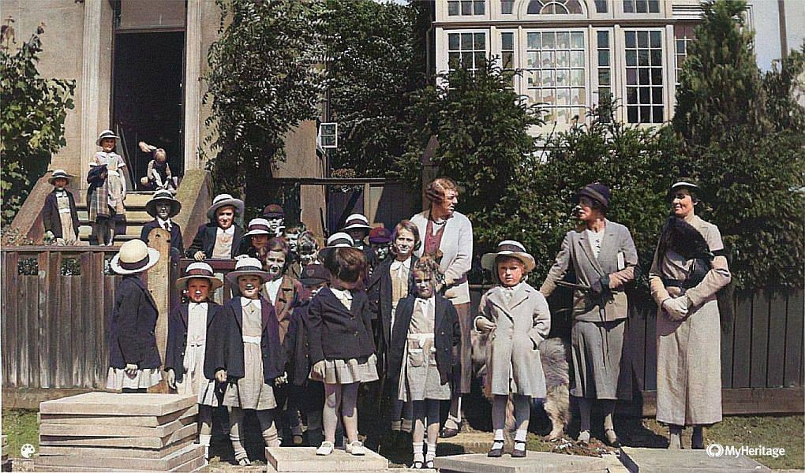
It appears that no.53 was bought or rented from 1936 probably in order to increase the space available to the school. According to Marion Thanisch (Facebook respondent) her mother and grandmother are pictured in the school photograph (above right). It was shot in 1934 and was her mother’s first day at school. The children attending appear to be aged

between 5 and 8 so the classes might have been mixed age. In 1939, no 53 was part of the school and the caretaker, Caroline Brentnall (born 19 January 1896) lived in no.55, so part of it was used as an apartment.

In 1946, the apartment was occupied by Audrey V M Darragh and Joseph Darragh. Former pupil, Jaki Piper went to the school aged four during World War 2, indicating that the school kept going, at least during some of the War. Another former pupil, Micky Harding, attended the school from 1949 when the uniform was red and he remembers the school comprising a classroom and a dining room – there must also have been a kitchen as they were served hot lunches. In 1949, while no.53 was again empty, no.55 was occupied by Alfred and Elsie Langton and Reginald Smyth. At that time the headmistress was Miss Groom (‘formidable’), and Miss Roberts and her sister, ‘Miss Molly’, were also teachers. The curriculum included ‘basic maths, reading and composition and even a little bit of French’. There were weekly dancing/ballet lessons from a Miss Behenna. According to a former pupil, Ellen Agar, during 1956-1959 the headmistress was Mrs Bradshaw, however, the school was owned by a couple who lived in Wellesley Road. The school must have closed around 1962.

1950-1965
The next evidence of occupation at no.53 is in 1950 when once again the house was divided into the two apartments. Florence I Beauchamp and her husband John W shared the property with the Elsons, Mary J and Sidney C. They lived in Pope’s Avenue for two years before moving on.

From 1953-1964 the house was occupied by the same residents. In no. 53B Dorothy M Gray lived with Derek L Gray with Antonina Wesolowski. In 53A Roy E Dyer lived with his wife, Evelyn F. In 1965 the Grays and Antonina continued to live in the house.

1966-2000
By 1970, apartment 53 was occupied by Miriam and Sydney C Rose, while 53A was the home of Linda C Elliot and Diane P and John L Young.

In 1979, 53A was occupied by Gwynfil M Connor and Richard F Connor while Caroline Yvonne Elizabeth Carta lived at 53.

In 1990, Caroline Carta still lived at 53 along with Bruce A Carta. 53A was empty.

In 2000, Caroline Carta was still at 53 along with Guiseppe Carta, while at 53A Polly Fletcher and Richard Nolan were the inhabitants.

Acknowledgements the Facebook group Twickenham and Teddington History for the photograph of the school and the reminiscences of former pupils.
This may not cover all previous occupants as I only sampled selected years of the Electoral Register. We also finish the house history in 2000 so that it does not include most recent inhabitants.

